**Industrial Internship Report on**

**” Banking Information Systems Prototype”**

**Prepared by**

**[Piyush Garg]**

|  |
| --- |
| *Executive Summary* |
| This report provides details of the Industrial Internship provided by upskill Campus and The IoT Academy in collaboration with Industrial Partner UniConverge Technologies Pvt Ltd (UCT).  This internship was focused on a project/problem statement provided by UCT. We had to finish the project including the report in 6 weeks’ time.  My project was (To develop Banking Information Systems Prototype)  This internship gave me a very good opportunity to get exposure to Industrial problems and design/implement solution for that. It was an overall great experience to have this internship. |

**TABLE OF CONTENTS**

1 Preface 3

2 Introduction 5

2.1 About UniConverge Technologies Pvt Ltd 5

2.2 About upskill Campus 10

2.3 Objective 12

2.4 Reference 13

2.5 Glossary 13

3 Problem Statement 14

4 Performance Test 16

4.1 Test Plan/ Test Cases 16

4.2 Test Procedure 16

5 My learnings 17

6 Future work scope 17-18

# Preface

Summary of the whole 6 weeks work: In The first week of Internship learned introductory concept of Java and then we have chosen our project topic and started to develop program for it using various concepts of Java and each and every day of the week we have inserted some part or tokens of the program and attempted a quiz about our internship company.

In Second week we have learned about whether java developer is a good career and then about why java is an independent platform and then attempted our first quiz Related to Java concepts for this week.

In third week read an e book about introduction to programming using java and tools used by full stack Java developer and learned new concept of Java string builder classes.

In Fourth week of learned concept related Interface, Abstract and method overloading and attempted second quiz related to Java

In Fifth week of Read about Success ladder to the corporate world and it’s objectives various activities, processes do’s and don’ts involved in it.

In Sixth week finally we have made report about weekly work and learning activities and project we have done.

Need of internship in any particular domain is must to give a fresher an experience to industrial environment and make him use to it and survive in it.

My project is to develop a Banking information system prototype and including various functionalities such as Registering for a Bank account and storing user’s information, deposit and withdraw etc.

Opportunity given by UCT to develop this project and to learn about various java concepts and give a unique experience of an industrial work

Program was planned with first to choose the problem statement and how to perform its solution then decided a professional format for each week progress report and So on following the same process for each and every week with attempting quizzes and watching videos and reading e books.

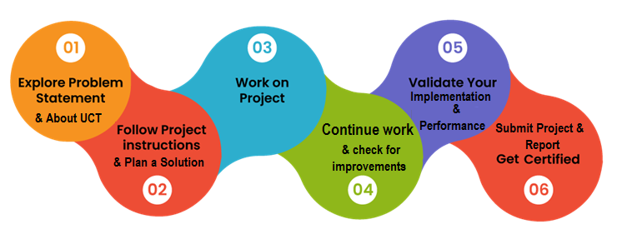

During my summer internship at Uniconverge Technologies, One of my biggest projects was developing a banking system prototype. Throughout my internship, I developed several new skills such as project management. I also gained valuable insights into programming industry and one of the most significant learnings for me was the importance of collaboration and communication in a team setting. I learned how to effectively communicate with my colleagues and supervisors to ensure that projects were completed on time and to the best of our abilities. I had a great experience working with my colleagues and supervisors at Uniconverge Technologies They were always willing to answer my questions and provide feedback on my work. However, with the help of my colleagues, I was able to prioritize my tasks and complete everything on time. Overall, my internship was a fantastic experience. I enjoyed the work I did and the people I worked with. I gained valuable skills and insights that will help me in my future career. I’m grateful for the opportunity to have worked at Uniconverge Technologies and would highly recommend it to other students looking for an internship.

Thank to all (Mr.Apurv, Mr.Kaushlendra Singh and Mr.Naresh), who have helped me directly or indirectly.

I’m grateful for the opportunity to have worked at Uniconverge Technologies and would highly recommend it to other students looking for an internship.

# Introduction

## About UniConverge Technologies Pvt Ltd

A company established in 2013 and working in Digital Transformation domain and providing Industrial solutions with prime focus on sustainability and RoI.

For developing its products and solutions it is leveraging various**Cutting Edge Technologies e.g. Internet of Things (IoT), Cyber Security, Cloud computing (AWS, Azure), Machine Learning, Communication Technologies (4G/5G/Lora WAN), Java Full Stack, Python, Front end**etc.

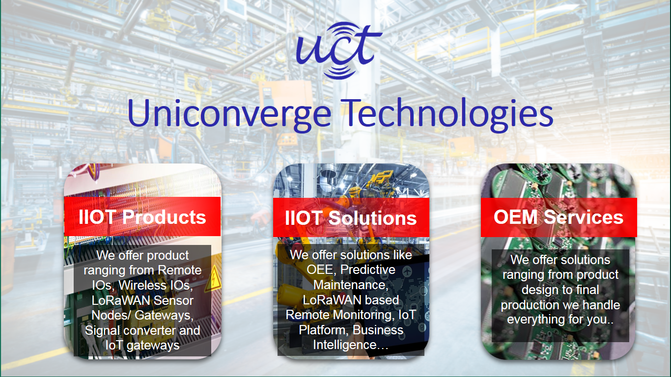

1. UCT IoT Platform **(****)**

**UCT Insight** is an IOT platform designed for quick deployment of IOT applications on the same time providing valuable “insight” for your process/business. It has been built in Java for backend and ReactJS for Front end. It has support for MySQL and various NoSql Databases.

* It enables device connectivity via industry standard IoT protocols - MQTT, CoAP, HTTP, Modbus TCP, OPC UA
* It supports both cloud and on-premises deployments.

It has features to  
• Build your own dashboard  
• Analytics and Reporting  
• Alert and Notification  
• Integration with third party application (Power BI, SAP, ERP)   
• Rule Engine

 

1. **Smart Factory Platform (****)**

Factory watch is a platform for smart factory needs.

It provides Users/ Factory

* with a scalable solution for their Production and asset monitoring
* OEE and predictive maintenance solution scaling up to digital twin for your assets.
* To unleased the true potential of the data that their machines are generating and helps to identify the KPIs and also improve them.
* A modular architecture that allows users to choose the service that they what to start and then can scale to more complex solutions as per their demands.

Its unique SaaS model helps users to save time, cost and money.

 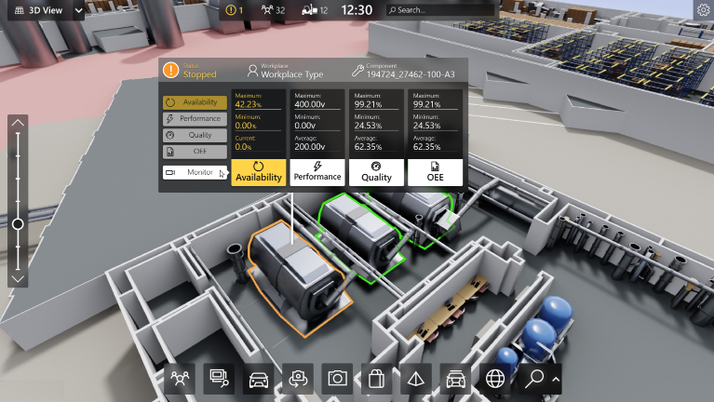

1. 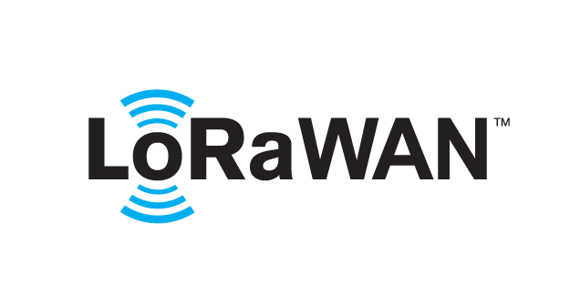 based Solution

UCT is one of the early adopters of Lora WAN technology and providing solution in Agritech, Smart cities, Industrial Monitoring, Smart Street Light, Smart Water/ Gas/ Electricity metering solutions etc.

1. Predictive Maintenance

UCT is providing Industrial Machine health monitoring and Predictive maintenance solution leveraging embedded system, Industrial IoT and Machine Learning Technologies by finding remaining useful life time of various Machines used in production process.



## About upskill Campus (USC)

Up skill Campus along with The IoT Academy and in association with Uniconverge technologies has facilitated the smooth execution of the complete internship process.

USC is a career development platform that delivers **personalized executive coaching** in a more affordable, scalable and measurable way.



Seeing need of upskilling in self paced manner along-with additional support services e.g. Internship, projects, interaction with Industry experts, Career growth Services

<https://www.upskillcampus.com/>

UpSkill Campus aiming to upskill 1 million learners in next 5 year

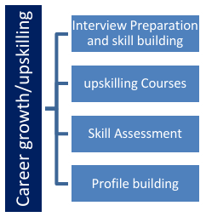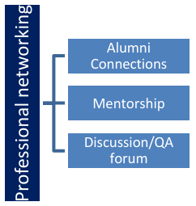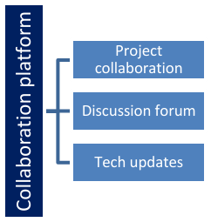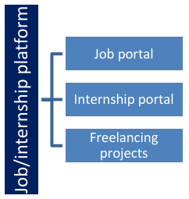

## The IoT Academy

The IoT academy is EdTech Division of UCT that is running long executive certification programs in collaboration with EICT Academy, IITK, IITR and IITG in multiple domains.

## Objectives of this Internship program

The objective for this internship program was to

 ☛ get practical experience of working in the industry.

 ☛ TO solve real world problems.

 ☛ TO have improved job prospects.

 ☛ TO have improved understanding of our field and its applications.

 ☛ TO have Personal growth like better communication and problem solving.

## Reference

[1] W3 schools

[2]Tutorials point

[3]Javaatpoint

## Glossary

|  |  |
| --- | --- |
| Terms | Acronym |
| Internet of things | IOT |
| Uniconverge Technologies | UCT |
| Up skill Campus | USC |

# 3. Problem Statement

In the assigned problem statement

**Context:** Our Company has given some projects and to choose one out of them

**Problem:** The problem is to develop Banking Information System in Core Java that provides a working preview of the key functionalities of a real banking system. The prototype should demonstrate the core features and flow of the system, showcasing its functionality and usability.

**Result:** The users will be familiar about how a banking system works in a realtime environment and how exchange of money in form of loans, fixed deposit and savings take place.

This problem statement clearly defines the issue at hand, explains the impact of the problem, and provides some potential solutions. This information would be helpful for a team to understand the problem and work together to find a solution.

**3.1** **Code submission (Github link): https://github.com/Piyush2570/Upskill-Campus-Piyush-Garg-**

# 4 Performance Test

## 4.1 Test cases: The program is working fine and output are as expected below:

## 4.2 Test Procedure

1. Set up the test environment by installing the required software and libraries.

2. Compile the Java program.

3. Identify the input data required to test the program.

4. Create test data that covers all possible scenarios.

5. Run the program with the test data and verify if the output is as expected.

6. Repeat step 5 for all test data scenarios.

7. If the program fails to produce the expected output, identify the root cause of the issue and fix it.

8. Rerun the program with the updated code and verify if the output is as expected.

9. Document the test results, including any issues found and resolved.

10. Repeat the test procedure whenever changes are made to the program to ensure that it continues to work as expected.

# 5. My learnings

Throughout this internship period, I learned about the fundamental concepts of computer programming programming language Java and gained experience in writing code to solve problems. I also learned about Efficient and error free code development methodologies and best practices for creating high-quality, maintainable code. Overall, this internship has provided me with a strong foundation in computer programming and introduced me well with the each and every concept like abstraction, interface etc. and through quizzes related to them.

# 6. Future work scope:

These Set of code Could be more efficient with less line of codes with introduction of new features, keywords in further versions that will consist of more and more functionalities all alone for example may be a keyword say Head can be introduced which will contain all line of codes and tokens of main method So due to this we do not need to write full body of main method at last or at beginning(depends on requirement of program) which will ultimately reduce that line of code and code will take less space and become more efficient and response time(output) will be faster.